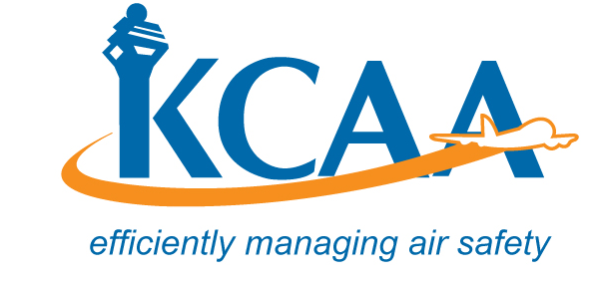 | Form: AC-AWS006-3

APPLICATION FOR LOCAL APPROVED MAINTENANCE ORGANISATION CERTIFICATE AND RATINGS AND RENEWAL

- Maintenance Organisation Name, Number, Location and Address |  |  |  |  |  |  | - Reasons for Submission
- Official Name of Maintenance Organisation: |  |  | Number: |  |  |  | Application for AMO Certificate and Rating Issue  Change in Rating  Change in Location or Housing and Facilities  Change in Ownership  Re-Certification / Renewal
- Location where business is conducted:

- Official Mailing Address of Maintenance Organisation

d. Line Maintenance Location
- Ratings Applied for: Ref: AMO Regs.11 & 12.
Aircraft |  | Engine – Propellers |  |  |  | Equipment & Instruments |  |  |  |  | Accessories  Class1 Mech. Acc.  Class2 Electrical Acc.  Class3 Electronic Acc.  Class4 APU.
Class 1 Composite Small Aircraft  Class 2 Composite Large Aircraft  Class 3 Metal Small Aircraft  Class 4 Metal Large Aircraft |  | Class1Piston <400hp  Class2 Piston>400hp  Class3Turbine Engine  Class1Fix Pitch Props  Class2All other Props |  |  |  |  | Class1Comm Equip.  Class2 Nav. Equip  Class3 Rader Equip.  Class1 Instr. Mech.  Class2 Electrical  Class3 Gyroscopic  Class4 Electronic
Specialised Service{List Process Specification(s)}
Scope of Ratings Applied for:

- List of Maintenance Functions contracted to other AMO’s:

- AMO Ownership and Incorporation Confirmation
Name of AMO Owner, {Include name(s) of all Owners, partners, or corporation name. State date of AMO incorporation}

I hereby certify that I have been authorised by the maintenance organisation named in Item 1 above to make this application and that the information given and the statements in the attachments hereto are true and correct to the best of my knowledge.
Date: | Authorised Signature: |  |  | Print Name of Authorised Signature: |  |  |  | Title:

