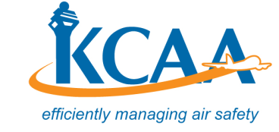

KENYA CIVIL AVIATION AUTHORITY
CIVIL AVIATION (SECURITY) REGULATIONS STAKEHOLDERS CONSULTATIVE FORUM
REGISTRATION FORM
Please Print or Type Clearly
Name in full
Mr./Mrs./Ms./Capt./Eng. /Dr.

Title or Official Position
Organisation/Company
Mailing Address
Telephone Number
Email Address
Date
Signature

After completing the registration form please send to: Kenya Civil Aviation Authority at the following email address: (avsec@kcaa.or.ke) on or before 31st December, 2019. This is for planning purposes.

