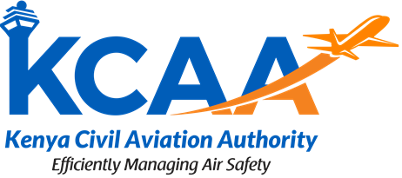
KEYA CIVIL AVIATION AUTHORITY
REVISED CIVIL AVIATION REGULATIONS
STAKEHOLDERS’ COMMENTS
Please Print or Type Clearly
- PERSONAL DETAILS

Name:
Job Title:
Organization / Company:
Contact (email):
Telephone:

- COMMENTS

No. | Regulation Title & Reference | Comment/Concern/Recommendation

No. | Additional Comments / Proposals

Note: Complete this comment form and forward a soft copy to the Kenya Civil Aviation Authority via email (regulations@kcaa.or.ke) preferably on or before 10 June 2024.

