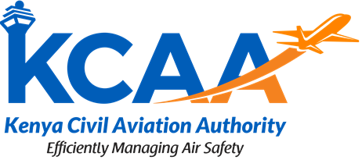 | Form  FORM: AC-AWS001-3  August, 2026

APPLICATION FORM FOR DESIGNATION & REMOVAL OF A CERTIFIED DESIGNEE

Date:
The Director General
Kenya Civil Aviation Authority
Aviation House
Jomo Kenyatta International Airport
P. O. Box 30163 – 00100
NAIROBI

RE CONFIRMATION OR REMOVAL OF CERTIFIED DISIGNEE IN RELATION TO AN IDERA

[Confirmation/Removal] of Certified Designee in relation to the Irrevocable De-registration and Export Request Authorisation dated [____________], relating to the [_____] aircraft bearing manufacturer’s serial number [____] and Kenyan Registration Marks [___] issued by [______] naming the undersigned as “Authorized Party” (the “IDERA”)

We, the authorised party under the IDERA, do hereby confirm that [______] is our certified designee for the purposes of exercising all of our rights and remedies under: (a) Article IX(1) of the Protocol to the Convention on Matters Specific to Aircraft Equipment opened for signature on 16 November 2001 at Cape Town, South Africa (the “Protocol”); (b) the IDERA; and (c) all applicable laws of [_____] implementing the foregoing. 2. We make this designation in accordance with Article XIII of the Protocol.

Name of Authorised Party / Company: _____________________________________________________

Name of applicant______________________________________________________________________

Signature of applicant: __________________________________________________________________

