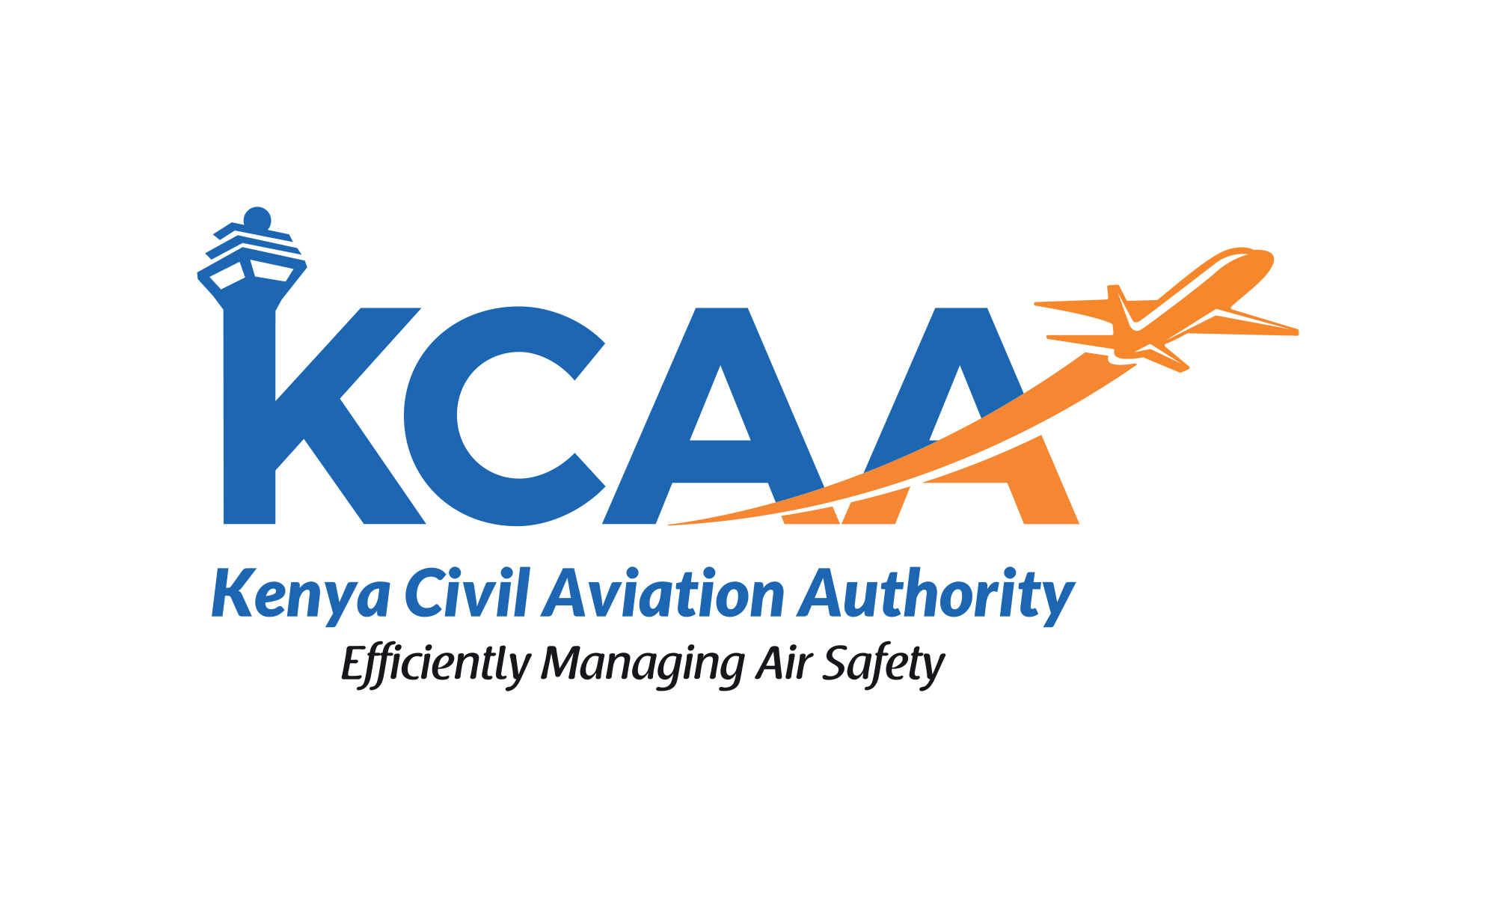 | FORM  FORM:AC-OPS001-5  November, 2024

AIR OPERATOR CERTIFICATE AMENDMENT JOB AID AND SCHEDULE OF EVENTS FOR MINOR AMENDMENT
Application for the amendment of AOC and its associated Operations Specifications.
PART A - APPLICANT DETAILS
Operator’s Name:
Contact Person Details:
Name:
Designation:
Phone:
Email:

PART B – AIRCRAFT DETAILS

Aircraft Registration | Aircraft Type/Model Designation | Aircraft Serial Number | Manufacturer | Type Certificate No.
Comments/Additional information (e.g. Specialised Operations):

PART C – APPLICATION ACTION ITEMS

Operator is required to fill in the column “Applicable Yes/No” and provide supporting documents where applicable.Error! Not a valid link.
Item No. | Description | Applicable  Yes/No | Inspector Initials | Date  Accepted or Returned | Date completed | Remarks
 | Letter of Intent for Aircraft Inclusion
 | Duly filled Pre-Application Statement of Intent (PASI) form.
 | Amended ASL with Aircraft Type
 | Management of change Report
 | Pre-application meeting
 | Formal Application Letter/Cover letter with attachments
 | Aircraft Inclusion Payment
KEY MANAGEMENT PERSONNEL BIO DATA
 | Head of Operations
 | Chief Pilot
 | Head of Maintenance
 | Head of Safety
 | Head of Quality
 | Statement Of Compliance
AOC COMPANY MANUALS
 | Amendments of Operations Manual Part A
 | Amendments of Operations Manual Part B (aircraft specific) + SOP
 | Amendment of Operations Manual Part C
 | Amendment of Operations Manual Part D
 | Amendment to Safety Management Systems Manual
 | Amendment to Quality Manual
 | Amendment to Ground Handling Manual
 | Amendment of Cabin Attendant Manual (if applicable)
 | Dangerous Goods Manual
 | Minimum Equipment List /CDL
 | Any other manuals
MANUFACTURER DOCUMENTS
 | Aircraft Operating Manual/FCOM/ODM
 | Aircraft Flight Manual/POH
 | QRH
 | Noise Certificate
 | Maintenance Control Manual
 | Aircraft Maintenance Program
 | Maintenance Contracts
 | Reliability Program
OTHER DOCUMENTS
 | Passenger Briefing cards & LOPA
 | Aircraft Checklists – Normal Abnormal and Emergency
 | Training contracts
 | Aircraft Lease agreement/ Ownership
 | KCAA Lease Approval
 | Maintenance Agreement
 | List of pilots qualified on type
 | List of cabin crew qualified on type
 | List of Flight Operations Officers qualified on type
 | Authorised Instructors on type
 | Designated Check Pilots
 | Simulator (if applicable)
SPECIAL APPROVALS APPLICATION PACKAGE
 | RVSM
 | EFB
 | PBN
 | ASETPA
ALL AIRCRAFT DOCUMENTS
 | Certificate of Airworthiness
 | Certificate of Registration
 | Aircraft Radio Station Licence
 | Weight and Balance Report
 | Certificate of Release to Service
 | Certificate of Insurance
 | Noise Certificate
AIRCRAFT INSPECTION
 | Refer to Local Aircraft Type Inclusion Inspection Checklist and Foreign Registered Aircraft Acceptance (CL:O-OPS029)

FOR CAA USE ONLY
PART D – APPLICATION RECOMMENDATION/APPROVAL ITEMS
Airworthiness Inspector Overall Comments:
Flight Ops Inspector Overall Comments:
 | Recommended/ Not Recommended | Name & Signature | Date
Airworthiness Inspector |  | Name: ………………………………  Signature: …………………………...
Flight Ops Inspector |  | Name: ………………………………  Signature: …………………………...
Cabin Safety Inspector |  | Name: ………………………………  Signature: …………………………...
MFOPs |  | Name: ………………………………  Signature: …………………………...

