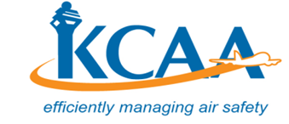 | FORM  FORM-M-PEL 010  August, 2019

APPLICATION FORM FOR ENGLISH LANGUAGE PROFICIENCY ENDORSEMENT ON A LICENCE

Application Type (Please tick the appropriate box)
I am applying for endorsement of:
☐ Initial | ☐ Renewal
Licence No.:
Applicant details:
Name (as it appears on ID/Passport):

Date of Birth: | Age (Min.16):
Gender: ☐ Male ☐ Female | Postal Address:
Email address:
ID/Passport No: | Nationality:
Licence held: | Phone Number:
Examinations: | Date of Exam
English Language Proficiency endorsement
Declaration:
I declare to the best of my knowledge and belief, that the information given in this application and attachments are complete and correct.
Signature Date
For Official Use Only:
Fees: Receipt No.:

Date: ☐ HQ ☐ WAP ☐ MSA

PEL Inspector’s

Name Signature

