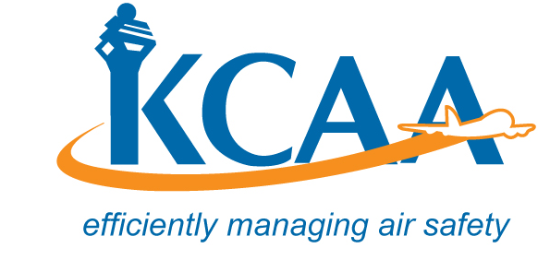 | Form: AC-AWS004-2
APPLICATION FOR ISSUE OF EXPORT CERTIFICATE OF AIRWORTHINESS.
1. COUNTRY AND PROPOSED DATE OF EXPORT:  I. AIRCRAFT DESCRIPTION |  |  |  | DATE
 | 2. NAME AND ADDRESS OF AIRCRAFT OWNER |  |  | 3. NAME AND ADDRESS OF OPERATOR
 | 4. CONSTRUCTOR |  |  | 5. YEAR OF MANUFACTURE |  |  | 6. AIRFRAME HOURS
 | 7. STATE OF DESIGN |  |  | 8. REGISTRATION MARKS:
 | 9. DESCRIPTION OF AIRCRAFT: | (a) New or Used |  | (b) Type |  | (c) Series
 |  | (d) Manufacturer’s Serial Number |  | (e) Type of Engine |  | (f) Number of Engines fitted
 |  | (g) Type of Propeller (where applicable): |  | (h) Seating capacity (including crew):
 | 10. MAXIMUM TAKE-OFF MASS OF AIRCRAFT |  |  | 11. MAXIMUM LANDING MASS OF AIRCRAFT.
12. Engines, APU and Propeller / Rotor Details:

Engine TBO Propeller/Rotor TBO

 | No.1 | No.2 | No. 3 | No. 4 | APU
Engine Type:
Serial Numbers:
Total Engine Hours:
Hours since overhaul
Propeller/Rotor Type:
Serial Numbers:
Total Propeller hours:
Hours since overhaul
Landing Gears
Serial Numbers:
Total hours (as applicable)

 | 13. DETAILS OF CURRENT CERTIFICATE OF AIRWORTHINESS |  | (a) ) Certificate Number |  | (b) Date of Issue of Certificate
 |  |  | (c) Date of expiry of Certificate |  | (d) Category
 | 15. WILL THE AIRCRAFT BE FERRIED ON STATE REGISTRATION MARK? YES/NO
 | 16. ARE THERE ANY ADDITIONAL REQUIREMENTS OF THE IMPORTING COUNTRY? (If yes, state)
 | 17. NAME AND ADDRESS OF IMPORTER
 | 18. WILL THE AIRCRAFT BE MODIFIED TO MEET THE SPECIAL REQUIREMENTS OF THE IMPORTING COUNTRY:
 | 19. NAME ,ADDRESS AND LOCATION OF APPROVED ORGANIZATION/LICENSED AIRCRAFT MAINTENANCE PERSONNEL WITH WHOM AIRCRAFT IS AVAILABLE FOR INSPECTION
III.  DECLARATION | 20. THIS DECLARATION MUST BE SIGNED BY THE REGISTERED OWNER OR A PERSON AUTHORISED ON BEHALF OF SAID OWNER.  “I hereby certify that the particulars given in this form are true in every respect. I further declare that all documents submitted in support of this application are true in every respect. The amount required by the current CAA Airworthiness Scheme of Charges to be paid on application is enclosed herewith. I also agree to pay any further charges payable in accordance and as may be notified to me by the KCAA.  NAME :---------------------------------------- DESIGNATION : ------------------------------------------------  SIGNATURE:--------------------------------------------- DATE: ---------------------------------------------

