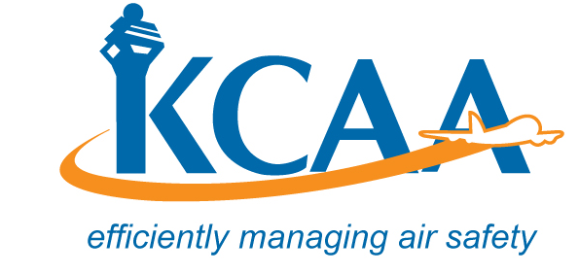 | Form: AC-AWS006-4
ORGANISATION ASSESSMENT STATEMENT (OAS)
To be completed by an applicant for CERTIFICATION, CERTIFICATE RENEWAL of Maintenance Organisation (To be Submitted with the Application)

Section 1A: To be completed by all applicants
- Name and mailing address of company (include business name if different from company name) |  |  |  | - Address of the principal (main) base where operations will be conducted
3. Certificate Expiry Date if Application is for Re-certification or Renewal:
Management and Key Staff Personnel. (Attach Personnel Data Form: Form: AC-AWS006-1 if application is for Certification and Re-Certification)
Name (Surname/First/Middle) |  | Title |  |  |  | Telephone & address

Section 1B:
5. | Air Operators Maintenance Support - AMO  Maintenance Organisation
6. Type of operation if AMO is Air Operators Maintenance Support
Passengers and Cargo Cargo Only Scheduled Operations Charter Flight Operations
7. Approved Maintenance Organisation Rating(s) Ref: AMO Regs. 11 & 12
Aircraft |  | Engine | Components |  |  |  |  | Accessories  Class1 Mech. Acc.  Class2 Electrical Acc.  Class3 Electronic Acc.  Class4 APU.
Class 1 Composite Small Aircraft  Class 2 Composite Large Aircraft  Class 3 Metal Small Aircraft  Class 4 Metal Large Aircraft |  | Class1Piston <400hp  Class2 Piston>400hp  Class3Turbine Engine  Class1Fix Pitch Props  Class2All other Props |  | Class1Comm Equip.  Class2 Nav. Equip  Class3 Rader Equip.  Class1 Instr. Mech.  Class2 Electrical  Class3 Gyroscopic  Class4 Electronic
Scope and Limitation of Rating Applied for:
Specialised Services Applied for (State Scope and Limitation):
Section 1C: Blocks 8 & 9 to be completed if AMO is AOC Maintenance Support
- AOC Aircraft Data |  |  |  | 9 Geographic areas of operations and route structure
Numbers and types of aircraft (By make, model, and series) |  | Passenger, Training or Cargo Operation

Section 1D: To be completed by all applicants
- Additional information that provides a better understanding of the operation or business – |  |  | Indicate attachments:  - Statement of Compliance  - Maintenance Procedures Manual (MPM)  - Contracted Maintenance Agreements  - AMO Training Programme
11. Declaration by AMO authorized person
Signature |  | Date (day/month/year). |  |  | Name and Title (Block Letters).

Section 2: for Official Use Authority - to be completed by the Manager Airworthiness
Received by (Name and Office): |  |  |  |  |  | Date received (day/month/year)
Date forwarded to Manager Airworthiness  (day/month/year): |  |  |  | For: Action Information only
Section 3. To be completed by the Airworthiness office
Date Received by Manager Airworthiness :
Assigned Task Number and Team Leader (TL): /
Date Received by Assigned Team Leader:
Manager Airworthiness Remarks:

